July 2021
Dear Parent/Carer
ARRANGEMENTS FOR URSULINE HIGH SCHOOL SPORTS DAY
DATE: Year 8 20th July, Year 9 21st July & Year 10 22nd July
START TIME: 9am registration at Morley Park
FINISH TIME: 1.45pm
VENUE: Ursuline Playing Fields, Cottenham Park Rd, Wimbledon, SW20 0SZ.
We are pleased to inform you that we will be running a series of sports/games days during enterprise week at our own playing fields, Morley Park. Registers will be taken at the venue and unauthorised absences will be recorded. All students are expected to make their own way to the above address and arrive promptly on time. We are delighted to inform you that we would like to invite parents / carers to spectate during the day & share in the celebration of the completion of a successful year. Please see below for Covid and event guidance.
Please ensure that your daughter is equipped with the following items:-
- Full Ursuline PE Kit- No other colour hoodies, jumpers or tracksuit bottoms allowed. Students must arrive/leave in their full PE Kit. Navy blue Ursuline tracksuit can also be worn if that is what you have instead of the skirt, or leggings beneath the skirt.
- Packed lunch/ water / snacks for the day.
- Sun cream/hat or cap - check the weather the day before & before you leave home. There will be some cover but not much.

Please make sure that your daughter is wearing PE kit uniform only as she will be sent back to school if she does not have the correct PE kit on. Students will be dismissed from Morley Park after the final presentations have been awarded at approximately 1.45pm. Students requiring support will be provided with supervision back to school on request. Parents are most welcome to support this event but cannot be in the student areas. There will be parent seating/standing area /access to toilets. Feel free to bring your own picnic!
Thank you for your continued support & we look forward to a fun yet competitive day,
Yours sincerely, Miss Doyle (Director of Sport).
_____________________
Caitriona.doyle@uhsw.com

COVID and event guidance for parents.
Please do not enter the site through any other gate. This is the second gate on the left as you get to car park. The other gates are for students only and member of the public.
Please be aware that though the restrictions regarding social distancing may change on the 19th, we are abiding by current COVID safety guidelines, which restricts assemblies of this type to a maximum of 30 persons. We will not be able to change this for the last week of school. In the interests of fairness, only one per household will be permitted and the first 30 parents to arrive will let through the gate.
Students will still be expected to wear their masks when travelling to and from Morley Park. This is so we can continue to protect our community during this last week of school.
Map of Morley Park / entrances & how to get there.
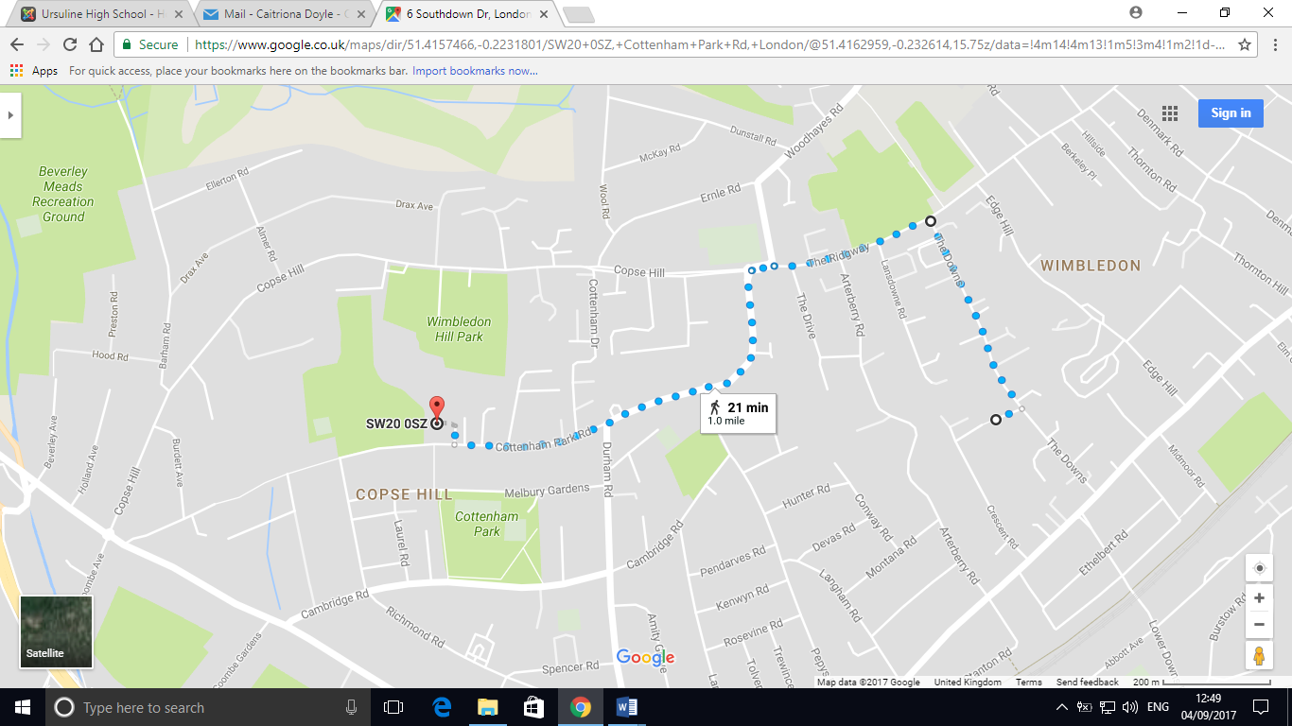
Students will enter the playing fields via the first gate in the car park, parents will enter through the second gate.
Ursuline Playing Fields, Cottenham Park Rd, Wimbledon, SW20 0SZ.

Students’ base area to register
Student entrance (like in PE lessons)
Parent area & parent entrance.
Student form area

