5 Ways to Wellbeing Easter Challenge

- Complete a task from each of the 6 areas each day. Vary what you do.
- Remember, if you are worried or feeling low to talk to a trusted adult. This is a challenging time for most people

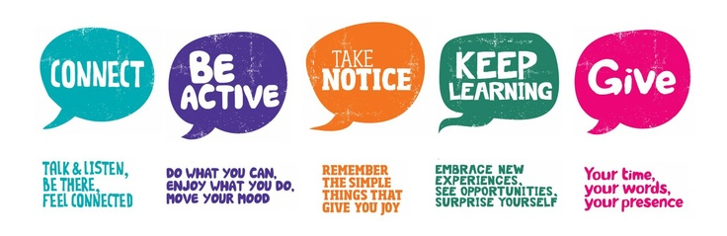

Connect |  |  | Be active
Telephone or video call a family member | Make a video to send to a member of your family |  | Go for a walk | Dance to 5 tracks of your favourite music
Sit down and have a family meal together and talk to each other while you eat | Telephone or send a message to a friend. Video call a friend |  | Go for a run | Try some yoga or pilates (use youtube)
Talk to your parents about how you are feeling about the current situation | Play cards or a boardgame with a family member |  | Do an online exercise class – youtube The Body Coach | If you have a bike go for a ride
Take Notice |  |  | Keep Learning
Do a mindfulness activity | Look around outside – notice the small things and tell someone what you notice |  | Read part of a book everyday | Try out a new recipe
Do a 3 minute breathing exercise | Enjoy some green space (garden, park, river) |  | Do a jigsaw  www.jigsawplanet.com | Read a poem
Savour the moment when you are eating a meal | Go for a walk, what can you see, feel, smell, taste? |  | Try a crossword or Sudoko | Research something new that interests you
Give |  |  | Other
Make a meal for the family | Participate in the Rainbow challenge |  | Write down 3 things you are grateful for each day | Do some colouring. Paint/Draw something
Help out with a household chore | Do a random act of kindness for someone |  | Watch some comedy | Enjoy a bath
Write a thank you note/email to someone | Express your gratitude to someone who has shown you an act of kindness |  | Spend some time with your pet | Get enough ‘quality’ sleep

