Staying Mentally, Physically and Emotionally Healthy
During the Corona Virus and
Possible Self-Isolation/Social-Distancing

Below is some advice and links to help keep yourself emotionally well as we all play our part in dealing with the Corona Virus. To keep yourself healthy:
- Wash your hands regularly for at least 20 seconds
- Follow the ‘catch it, bin it, kill it’ advice for coughs and sneezes
- Engage in the 5 ways to wellbeing
- Let people know if you are struggling
Who can support me?
- Talk to a trusted family member or a trusted adult. If you are finding something difficult don’t keep it to yourself or pretend everything is ok.
- If you cannot ‘talk’ let them know you need some support by sending them a message/emoji/leaving them a note they will find
- Kooth – www.kooth.com Online support services for young people, 11-25 years. Offers free online councelling from 12pm to 10pm Monday to Friday from 6pm to 10pm Saturday and Sunday
- If you access any specific support ensure you have the contact numbers and get in touch with them is you need support

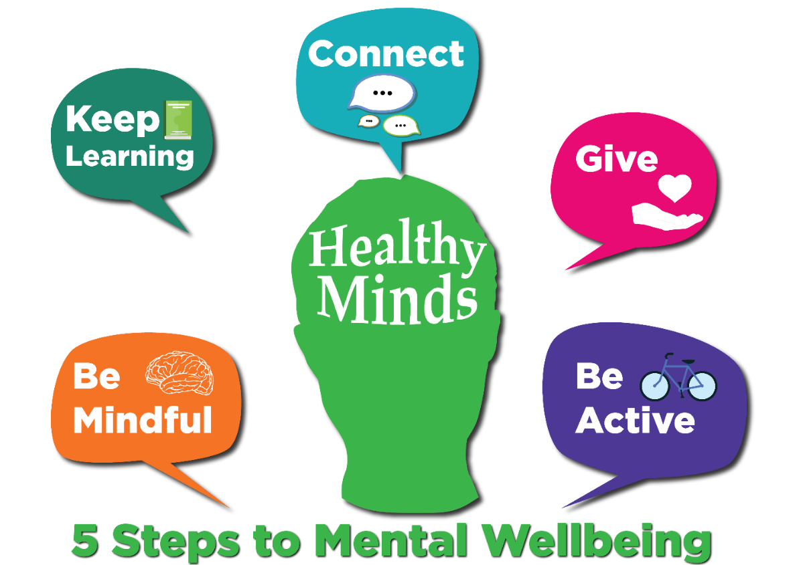

Tips to support your Mental and Emotional Wellbeing
(Protective factors)
Be creative
(curious & active)
Exercise
(active)
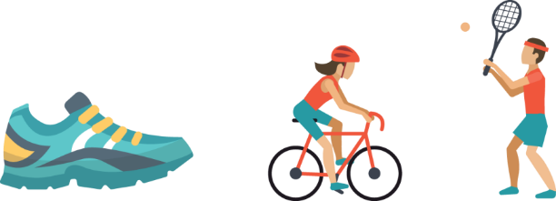
Having creative outlets can be great for our mental wellbeing. Get out a sketch pad, or paints, pick up a camera, turn your hand to some poetry or song writing, pick up a musical instrument, design a webpage, teach yourself how to code.
Here is a list of free, online, boredom-busting resources https://chatterpack.net/blogs/blog/list-of-online-resources-for-anyone-who-is-isolated-at-home

Keeping active can be a great way of keeping mentally healthy. If your normal mode of exercise is inaccessible try going for a bike ride or a run (there are great “coach to 5km” programmes for beginners). If you are in isolation try out an online home workout video, like The Body Coach TV. A whole variety of different styles of online workouts from HIIT sessions, to dance or yoga can be found here: www.womenshealthmag.com/uk/fitness/strength-training/a704114/best-youtube-workouts/

Eat well
(discerning)
Sleep well
(discerning)
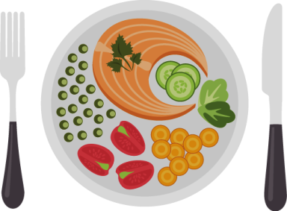
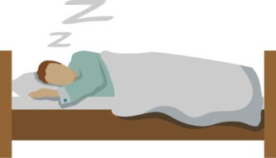
- Health body, health mind. Eat a good balanced variety of foods.
- If you are in isolation or working from home try and keep to certain times of the day to eat, and don’t be tempted to snack constantly.
- Keep your fluids up, but be careful not to increase your caffeine consumption.

Anxiety and changes of routine can affect our sleep. Doing what we can to help ourselves sleep well can help our mental health and resiliency.
- Try to keep to a normal sleep pattern
- Don’t be tempted to nap in the day
- Switch off electronic devices a couple of hours before bed.
- Have a distinct winding down routine in the hours before bed. Go for a walk, have a warm shower/bath, read a book.
- Don’t drink caffeine or energy drink for a number of hours before bed.
- To avoid ideas and anxieties whirring in your head disrupting your sleep, keep a notebook by your bed that you can write down thoughts, or anxieties in, this can help externalize them, and stop them churning in your head.

Be grateful
(gratitude)

- Be thankful for the small things.
- If you are isolated with other people, make an effort to express your gratitude for the everyday acts of kindness.
- Take the opportunity to write that thank you note/email that you have been meaning to send.
- Keep a gratitude diary -challenge yourself to write down 3 things you are grateful for each day.

Connect with
friends and family
(loving)
Focus on the positive
(intentional & hopeful)

This is not about being naïve and looking at the world through rose tinted spectacles, but at the same time we can be drawn to focussing on the negative things, so try and focus on the positive.
If you are in isolation you might be tempted to make mental lists of all the things that you now cannot do, all the freedoms you no longer have. That is fine, and having someone you can talk to about your frustrations is good, but also try and look for, and focus on, the positives. What can you positively use some of this extra time to do?
Try and focus on positive self-talk:
“I can focus on doing my bit and doing my bit well”
- If you end up isolated, keeping connected with friends and family by whatever means you can will be important for you.
- Use the opportunity to ring a friend who you haven’t spoken to in a while. Use video calling technology to remotely connect with friends and family.
- Think of others who might not have as many people to connect with and speak to or message them.

Be mindful of
your own feelings
Do mindfulness exercises
(attentive & discerning)
Challenge negative thoughts
(intentional)

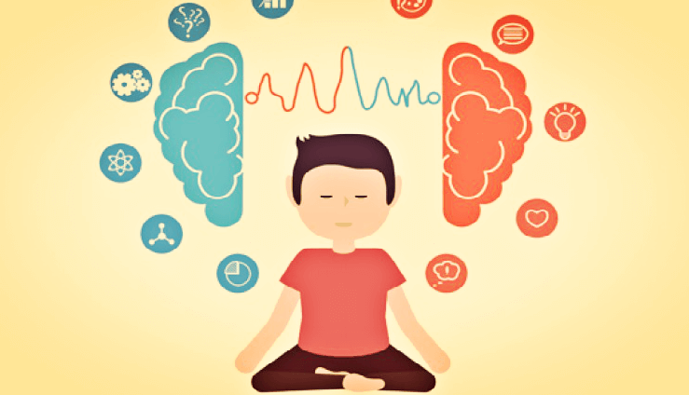
Use mindfulness exercises.
- https://bemindful.co.uk/
- http://self-compassion.org/category/exercises/
Negative self-talk can become a bad habit, and it is never a true balanced reflection.
Try and catch yourself if you are dwelling on negative thoughts, and challenge yourself to reframe them in a more balanced way.
Talk your thoughts through with a trusted adult.
Read a Good Book
(curious, compassionate)

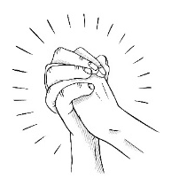
Pray
(faith-filled & hopeful)
Reading a good book can take you into another world, take you out of your own situation and worries and immerse yourself in the lives of the characters in the book. Not only is this a good form of entertainment and distraction to fill the time, it can help you focus outside of yourself, help you empathise with others and give you perspective.
- Lent is a great time to get into some new good prayer habits.
- Join in our daily prayer through registration
- Read a Gospel
- Read some of the New Testament books you are less familiar with.

Tips for working from home:
- Get up and get dressed ready for work so you are in work mode.
- Set aside a space for work.
- Try to avoid using your bedroom to work in, if possible.
- Follow your school timetable for logging into lessons and completing the work.
- At the end of the school day, tidy your work away and engage in wellbeing activities (see suggestions above)

Tips for Self-Isolation
- If you are in isolation, try to bring variety and stucture into your days.
- Limit how much social media you access and only follow news from reputable sources.
- Know it is OK to be anxious. Some people are more anxious, some people are more laid back, try and be understanding of others around you if their response is different to how you are feeling.
- Keep active, see the tips give above.
- If you are isolating with others, anticipate that this close proximity living can be challenging for everyone. Talk to each other, air frustrations early but in a gentle way. Try to understand that other people might have different needs and emotional responses than you to the new situation. Make an extra effort to be patient with each other, and to look out for ways to do kind things for each other.
- Self-care – do things to look after yourself, take a long bath, cook your favourite food, use some essential oils, listen to your favourite album, watch some comedy.
- Watching TV series, using social media, playing computer games can be a great distraction, but bingeing on these can leave you feeling low and sapped of energy, and if you are doing this late in the evening this can also adversely affect your sleeping which can have a significant impact on your mental health. Try and set yourself reasonable limits on how much time you will spend in front of a screen, and mix up screen time with other non-tech-based activities (do some cooking, read a book, listen to music, do some gardening).

