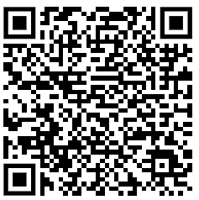
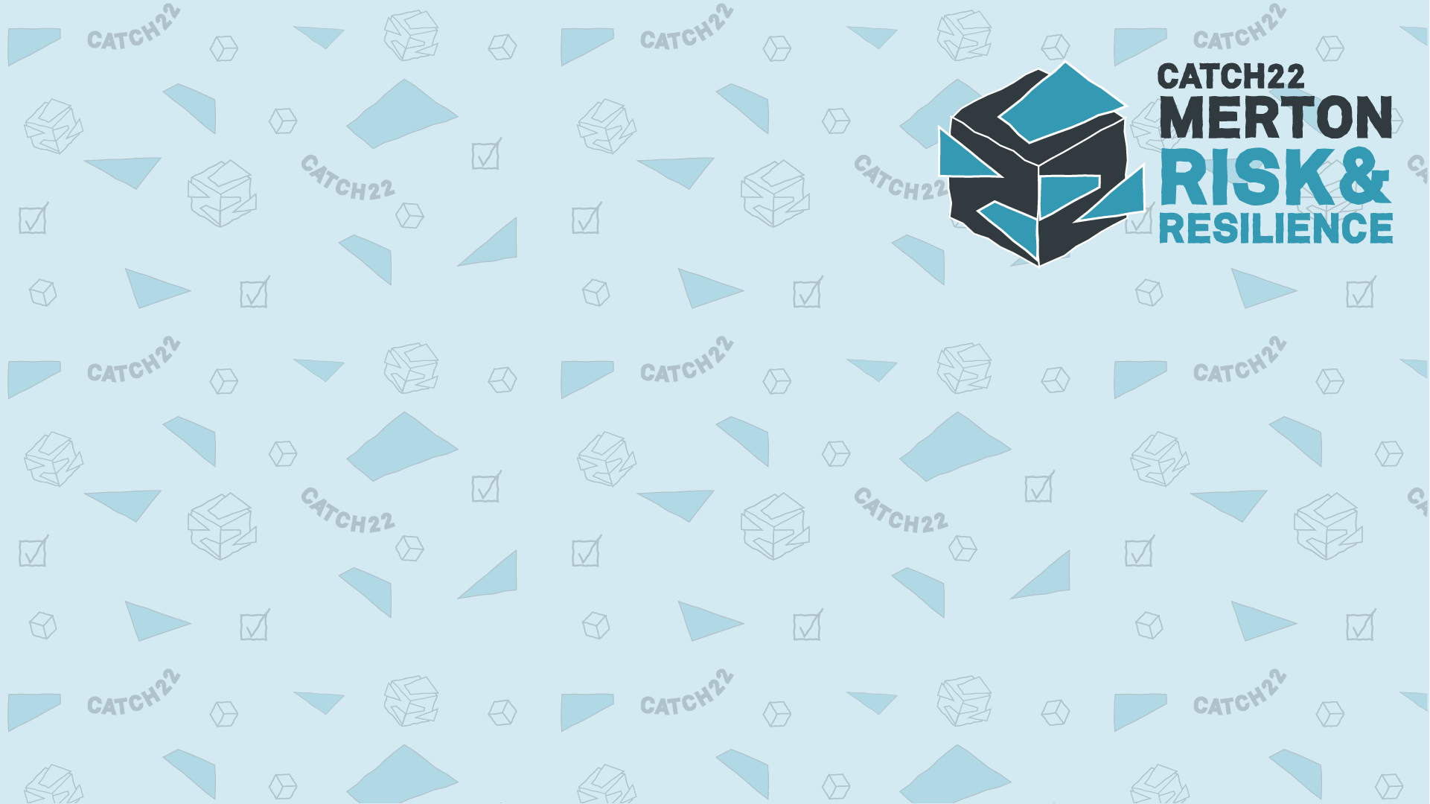
📅 Date: March 17th 2026
📍 Location: Eventbrite
🕒 Time: 18:00 – 19:00
Don’t wait until it’s too late!
Empower yourself with knowledge and tools to keep your child safe.
👉 Reserve your spot today!

Join our FREE Vaping Awareness Workshop and get the facts you need to protect and support your family!
✅ Know the Basics – What is vaping really?
✅ Understand the Law – What’s legal and what’s not?
✅ Spot the Difference – Identify illegal vapes and protect your child
✅ Discover the Risks – Health, environmental, and financial dangers
✅ Learn How to Help – Proven techniques to quit and manage stress
✅ Get Support – Find out what help is available for young people and adults
✅ Understand the Impact – Why vaping affects young people differently
Parents Information Webinar: Vaping

